Music Theory Name ________________________
Mr. Hosterman Mid-Term Exam

Part I – Music History – Choose the correct answer

______ 1. The following are Eras of Musical History, except
  - Medieval e. Neo-Classical
  - Renaissance f. Romantic
  - Baroque g. 20th Century
  - Classical

______ 2. Music notation began using these symbols which translate to “gesture”
- Notes
- Beats
- Neumes
- Staffs

______ 3. The first form of written music was
- Gregorian Chant
- Organum
- Sonatas
- Trio

______ 4. This type of music developed second and has two melodic lines
- Gregorian Chant
- Organum
- Sonatas
- Trio

______ 5. This Era of music history had the strongest sense of Rhythmic drive
- Classical
- Romantic
- Medieval
- Baroque
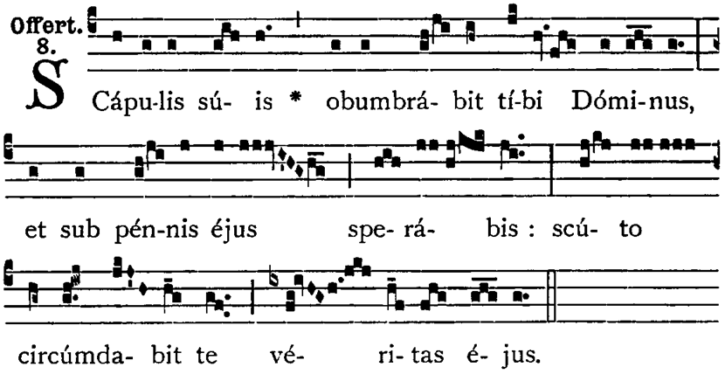
______ 6. The following is an example of:
- 20th Century Music
- Gregorian Chant
- Organum
- Musical Artwork

Part II – Fill in the Blank

- List the Four Principles of Music.

_______________________ _______________________

_______________________ _______________________

- Compare and contrast how Woodwind and Brass Instruments produce a sound.

- The STAFF is made of ________ lines and ________ spaces.

- A piano has ______ keys and contains ______ octaves.

- Write the formula for a MAJOR Scale

_____ _____ _____ _____ _____ _____ _____

- Identify the names given to the 7 notes of a scale-

1^ - TONIC 5^ - __________________

2^- ___________________ 6^ - __________________

3^- ___________________ 7^ - __________________

4^- __________________

- There are four notes that make up a SEVENTH chord. What are their names?

_________ _________ _________ _________

- Draw a treble and bass clef.

________ ________
________ ________
________ ________
________ ________
________ ________

Part III – Definitions – Match the term or symbol to its correct definition.

- Diabolus in Musica – augmented 4th

- Treble and Bass staff connected by a bracket

- Name given to a seventh chord built on the 5th scale degree

- Lowers a note by a half step

- Name for this - Eb = D#

- This note MUST resolve UP

- Raises a note by a half steps

- Nickname given to the Treble clef

- Defines the number of beats per measure

- Small lines used to extend the staff

- A single sharp or flat which appears within the music

- Tonality associated with SADNESS

- Vertical line dividing a staff into measures

- Symbol that cancels a sharp or flat

- Lowers a note by two half steps

- A grouping of sharps or flats at the beginning of a piece of music

- Two or more notes sounding together to create a pleasant sound

- Tonality associated with HAPPINESS

- Writing or playing a melody backwards

- Two or more notes sounding together to create an unpleasant sound

_____ 1. Leger Line

_____ 2. Bar Line

_____ 3. Grand Staff

_____ 4. Major

_____ 5. Minor

_____ 6. Consonance

_____ 7. Dissonance

_____ 8. Time Signature

_____ 9. Key Signature

_____ 10. Tritone

_____ 11. Leading Tone

_____ 12. Retrograde

_____ 13. Enharmonic

_____ 14. Accidental

_____ 15. Double Flat

_____ 16. Natural

_____ 17. Sharp

_____ 18. Flat

_____ 19. Dominant Seventh

_____ 20. G Clef
Part IV – Music Theory Application

Using the formula for a Major Scale, apply the correct sharps or flats to the following scales to make them correct. (The first and last pitches are correct)

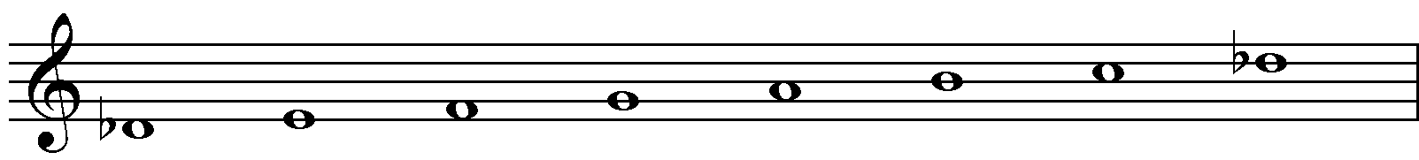

D flat Major

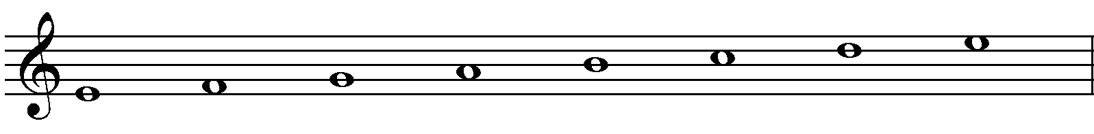
E Major

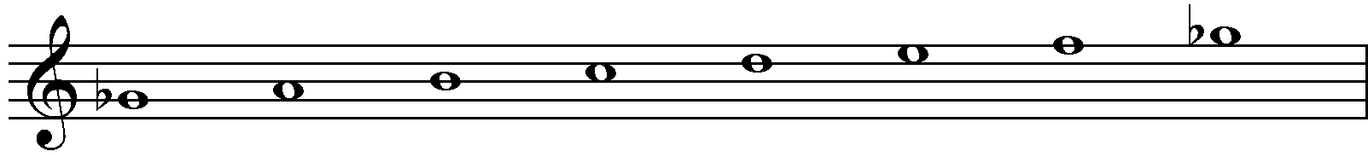

G flat Major

Identify the intervals below. By moving one note up or down, write the inversion of each interval and then identify the inversion.

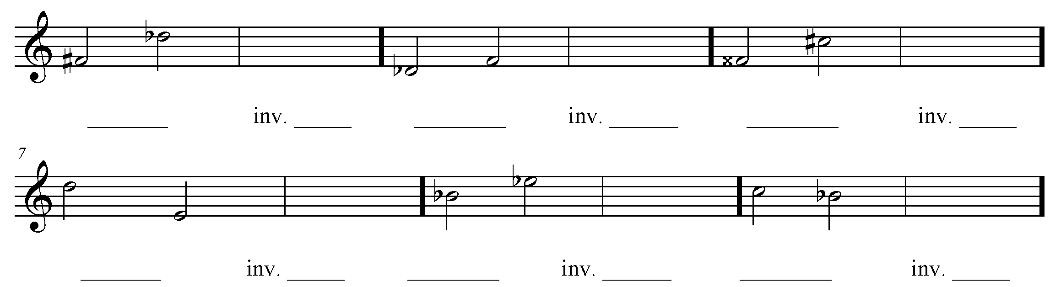

Identify the following chords and write the two forms of the chord not given.
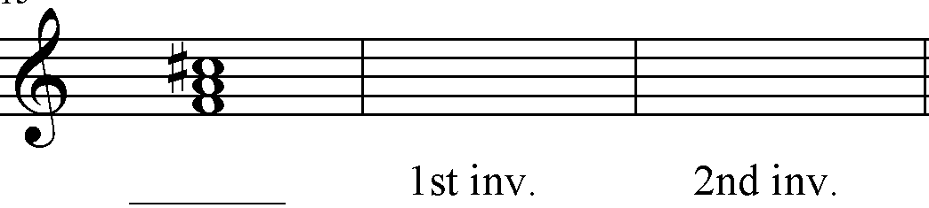
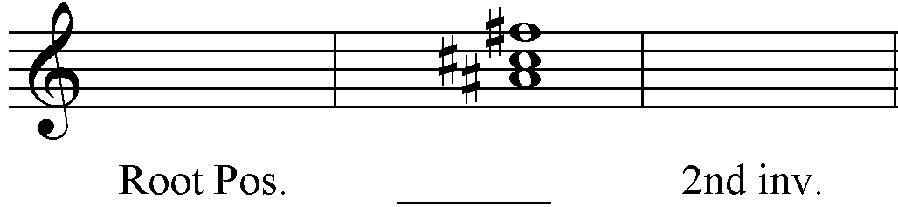

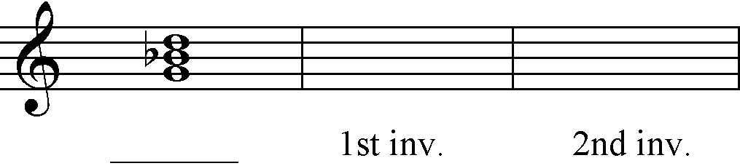
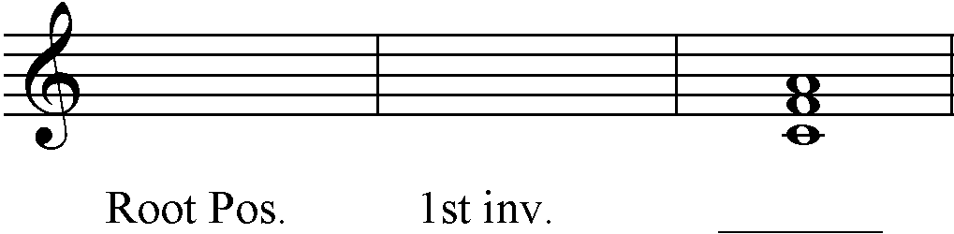

What is the symbol for a Triad in First Inversion ? ______________

What is the symbol for a Triad in Second Inversion ? _____________

What is the symbol for a Seventh Chord in First Inversion? _____________

What is the symbol for a Seventh Chord in Second Inversion? _____________

What is the symbol for a Seventh Chord in Third Inversion? _____________

Identify the various Roman Numerals that may be given to the following chord in different key signatures.
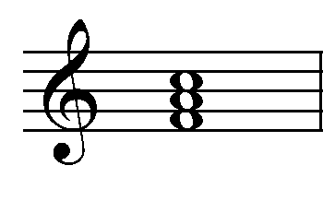
Chord Key

Ex. I in FM

______ in CM

______ in Bb M

______ in b flat minor

______ in a m

Provide the Roman Numeral Analysis for the following musical example. Remember to look for and notate any inversions.

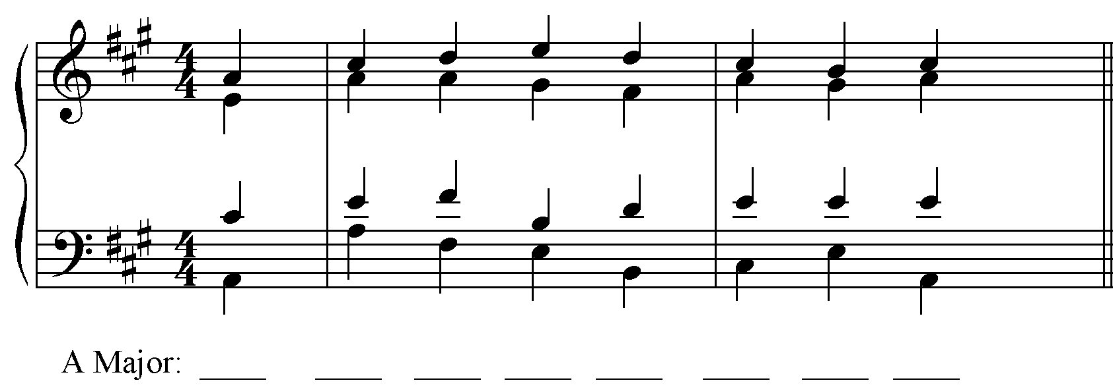

Fill in the Alto and Tenor voices for the following musical example.
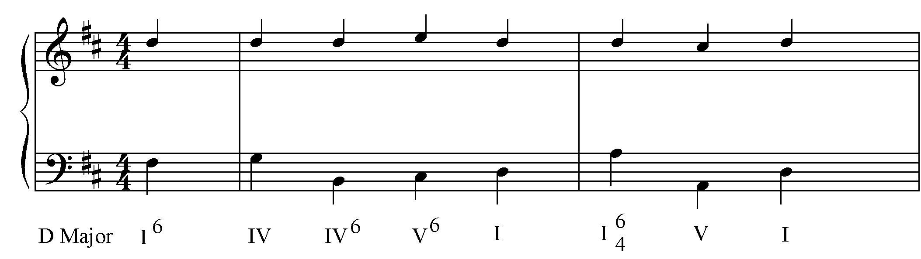

What note is the leading tone in this key? ____________

What note MUST the leading tone resolve to in this key? ____________

Below is a copy of the last measure from the above excerpt. Re-write the Tenor and Alto parts to make a Dominant Seventh Chord on beat 2. Be sure to resolve each tone correctly.

7

Short Answer :

What is the purpose of Dominant Seventh Chord? What are some considerations that need to be addressed when using them?

Extra Credit (2 points)–

Identify the 7th note of a C7 chord. Go up a P5th, down a P4th, up a minor 3rd, up a Major 3rd. This note is the bass note of a IV₆ chord in the key of ____. In the same key, identify the 7th note of the Dominant Seventh Chord.

